I2C(Inter-Integrated Circuit)

Configuration in STMCUBEMX:

1.Select SYS🡪serial wire.

2.Select I2C1🡪selectI2C.

3.Select GPIO_Output at pin PD15 and generate code.

4. Open main.c make the following changes in code.

5.Define in /* USER CODE BEGIN 0 */

uint8_t i2cBuf[8],i,Deviceaddr;

**float** x,y,z;

**float** xacc,yacc,zacc;

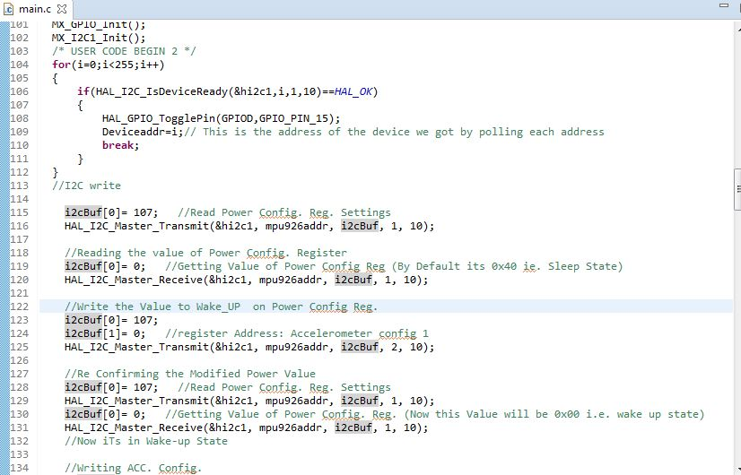

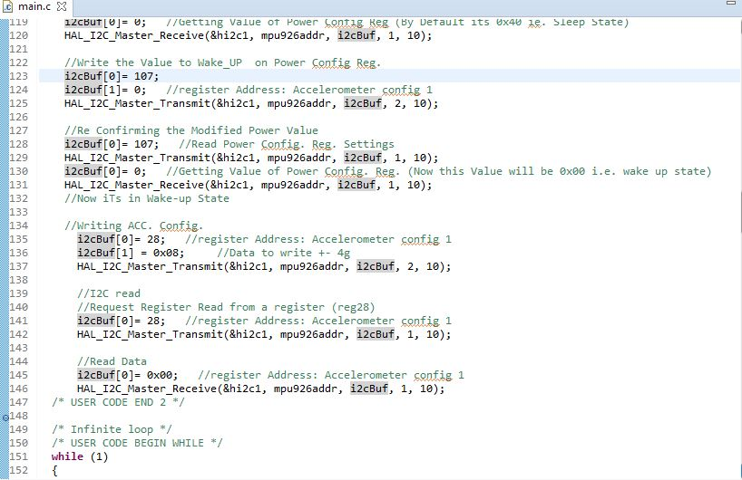

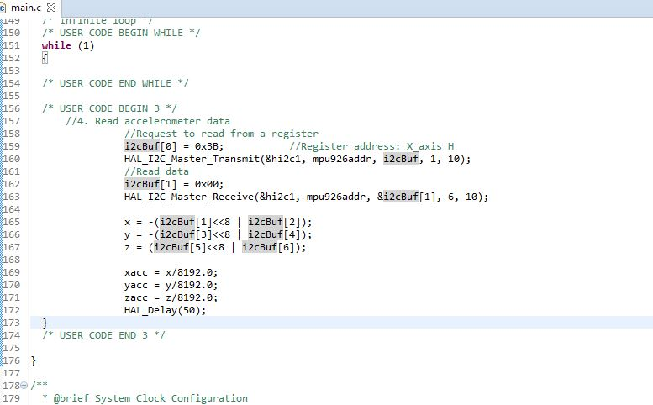

6.Build the project and Run.